Ex1 Ex2

Ex3 Ex4

In Ex1, for A = 4J, the exact eigenvalues are all 0, and exact eigenvectors are [1,0,0,0,…]T, [-1, 1.05219e-291,0,0,…]T, and [1, 1.05219e-291,0,0,…]T. The condition numbers of the eigenvector matrix computing for ten random perturbations Q are 2496058182.53716, 17160427517.5256, 5248922285.14607, 6452564901.08892, 13478254296.4287, 3134551169.45479, 4643707360.30116, 4683312663.2115, 10396537251.0819, 2736524056.4801.

We can find that most of these condition numbers are from 1e^10 to 5e^10. If we perturb the equation from zn = 0 to zn = δ, the solution will decrease. As δ gets larger, the solution gets larger as well.

In Ex2, for A = 4J+4J2, the exact eigenvalues are all 0, and eigenvectors are [1,0,0,0,…]T, [-1, 1.05219e-291,0,0,…]T, and [1, 1.05219e-291,0,0,…]T, which are same as those in Ex1. The condition numbers of the eigenvector matrix computing for ten random perturbations Q are 5580248633.36534 20903069599.3746, 5338247720.44868, 9824117434.18279, 5093397451.75752,

5000170078.04864, 3930065831.10834, 6218579270.22663, 19855559624.4365 4467255975.31548. We can find that most of these condition numbers fluctuate around 5e^10.

In Ex3, for A = - (LD)-1U, the condition numbers of the eigenvector matrix computing for ten random perturbations Q are 1417000362.73712 811981548.77583 682980042.700847 2611074408.13903 961170593.436261 6072009038.50794 1707229882.49536 1830077014.67361 3525739776.3822 2528830179.18396.

We can find that most of these condition numbers fluctuate around 1e^10. λ = 0 is an eigenvalue of A.

In Ex4, the condition numbers of the eigenvector matrix computing for ten random perturbations Q are

7836450637.83039 11721371764.4364 51003839774.0684 11328785306.746 11666131798.1925. 8527912145.40173 24779904063.0207 16512399094.497 9185753874.48598 21317165299.5545, which mostly are from 1e^10 to 2e^10.

In Ex5, as n grows from 1 to 10, the eigenvalues increase from -2 to 2. The reason for obtaining quite different results with perturbations from Ex4 is that in Ex5, B is generate randomly, so A is randomly generated. Then, results in Ex5 are quite different from those in Ex4.

Ex1 Ex4

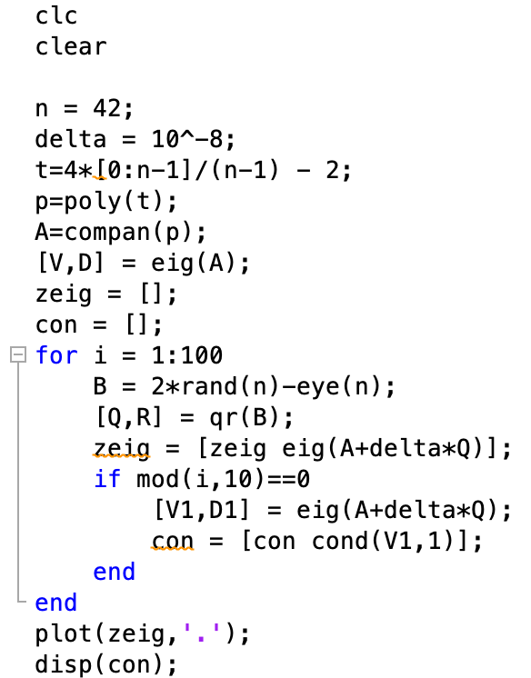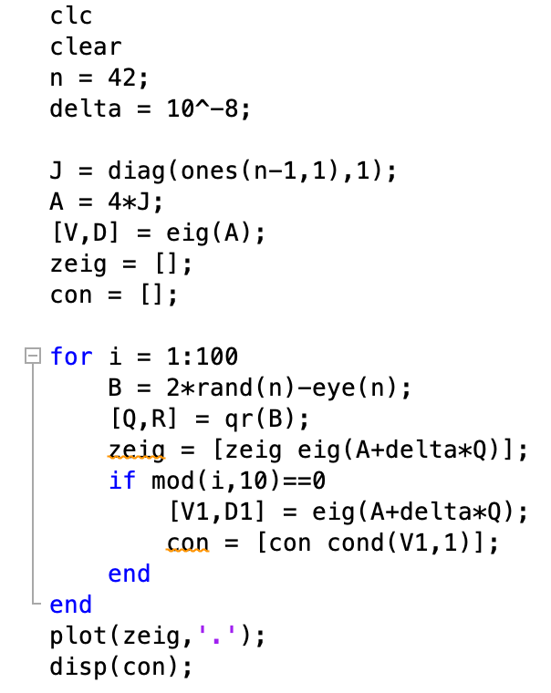

Ex2

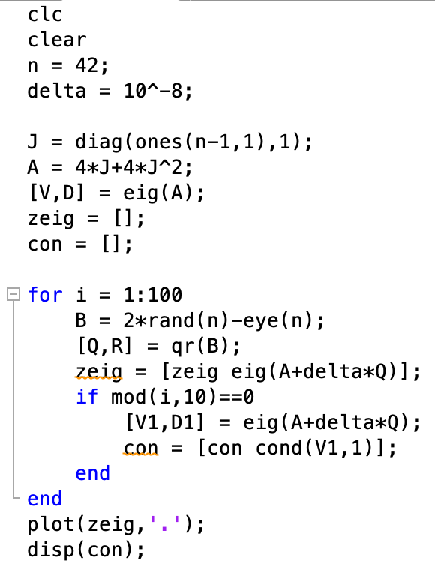

Ex5

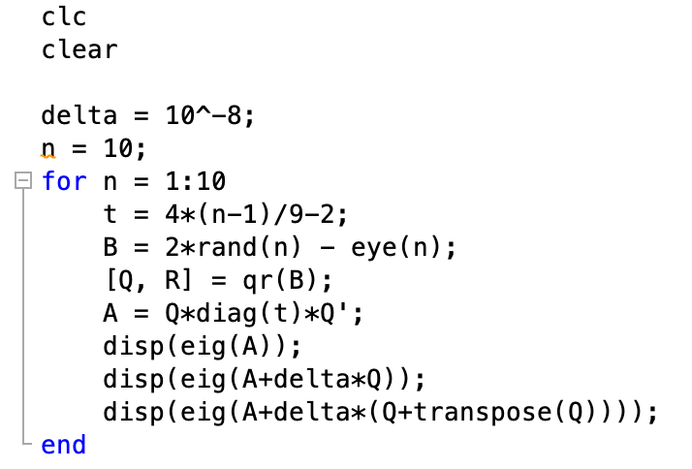

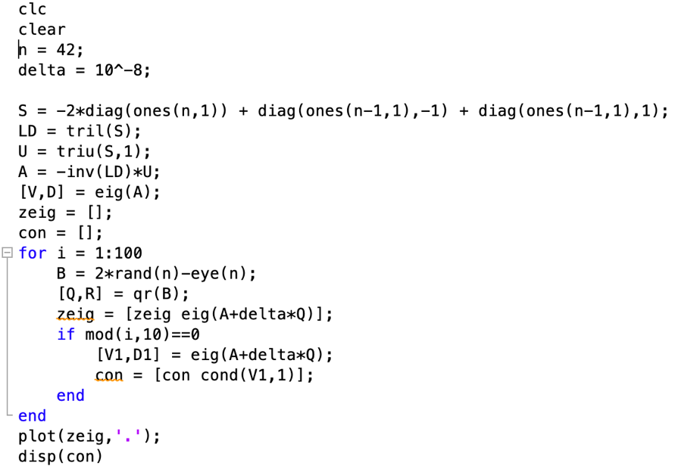Ex3